

UCDF1405ICTSE

AICT004-4-2-OS

Group Assignment

Ng Ho Kit TP035012

Ng Ji Syuen TP034728

Teh Kah Jun TP034945

Name of Lecturer: Miss Vijayalaxmi Amuthan

Due date: 21th April 2016

Table of Contents

1. Gantt Chart 1

2. Workload Matrix 2

3. Research and Investigation 3

3.1. Introduction – Operating System 3

3.2. Introduction – Windows 7 3

3.3. System Hardware Requirement 4

3.4. Comparison Memory Management between Windows 7 and Windows 8.1 5

3.5. Windows 7 Clean Installation Process (boot from DVD) 6

4. Analysis 15

4.1. User Interface 15

4.2. Process Control Management 21

4.3. Deadlock management 22

4.4. Memory Management 24

4.5. Secondary Disk Scheduling Management 27

4.6. Standard Support 28

5. Limitations / Extensions 32

6. Minutes of Meetings 34

6.1. Meeting Minutes #1 34

6.2. Meeting Minutes #2 35

6.3. Meeting Minutes #3 36

6.4. Meeting Minutes #4 37

6.5. Meeting Minutes #5 38

7. References 39

# Gantt Chart

# Workload Matrix

|  |  |  |  |
| --- | --- | --- | --- |
| **Task** | Teh Kah Jun  TP034945 | Ng Ho Kit  TP035012 | Ng Ji Syuen  TP034728 |
| **Gantt Chart** |  |  | ✓ |
| **Introduction** | ✓ | ✓ | ✓ |
| **System Hardware Requirement** |  | ✓ |  |
| **Memory Management Comparison between Windows 7 and Windows 8** | ✓ |  |  |
| **Installation** | ✓ |  |  |
| **User Interface** |  |  | ✓ |
| **Process Control Management** |  |  | ✓ |
| **Deadlock Management** |  | ✓ |  |
| **Memory Management** | ✓ |  |  |
| **Secondary Disk Scheduling** | ✓ |  |  |
| **Standard Support** |  | ✓ |  |
| **Limitation / Extension to Case Study** |  |  | ✓ |
| **Minutes of Meetings** |  | ✓ |  |

# Research and Investigation

## Introduction – Operating System

Operating System is the most important program that runs on most general – purpose computer such as personal computer, desktop, notebook, smartphones and tablets to perform basic tools such as recognizing input from input devices and sending output to output device, controlling peripheral devices and others. Every general- purpose computer must owned an operating system to run system software and application software. There are many different operating system however, nowadays most of the people prefer Windows and UNIX/LINUX-based operating system.

## Introduction – Windows 7

Windows 7 is a personal computer operating system that released commercially in year 2010, October. According to Microsoft, the codename project for the Windows 7 are Vienna or Blackcomb. The Windows 7 was preceded by Windows Vista that released 3 years ago in January 2007. Windows 7 is available in 6 different editions, that is, Starter, Home Basic, Home Premium, Professional, Enterprise and Ultimate Edition. The Home Premium, Professional, Enterprise and Ultimate Edition are only available in retailer shops.

By comparison of Window 7 with the previous Window versions, Window 7 has been improved on the boot speed and graphical components. Window 7 provides higher quality Graphical User Interface (GUI) and large flexibility on customization by users. Window 7 has no necessity for the drivers to support but previous Window versions do. Window 7 has also made a maximum improvement on security and support.

## System Hardware Requirement

|  |  |  |
| --- | --- | --- |
|  | Basic | Recommended |
| **Processors** | 1 gigahertz 32bit or 64bit processor. | 1 gigahertz or faster 32bit or 64bit processor. |
| **Memory** | 1 gigabyte of RAM | 1 gigabyte of RAM for 32bit processor or 2 gigabyte of RAM for 64bit processor |
| **Hard Disk** | 16 gigabyte of hard disk space | 16 gigabyte of hard disk space for 32bit processor or 20 gigabyte of hard disk space for 64bit processor. |
| **Video Graphics** | Support DirectX 9 graphics with 128MB of memory to enable Aero theme. | DirectX graphics device with Windows Display Driver Model (WDDM) 1.0 or higher driver. |

*Table 1: System Requirement for Windows 7*

## Comparison Memory Management between Windows 7 and Windows 8.1

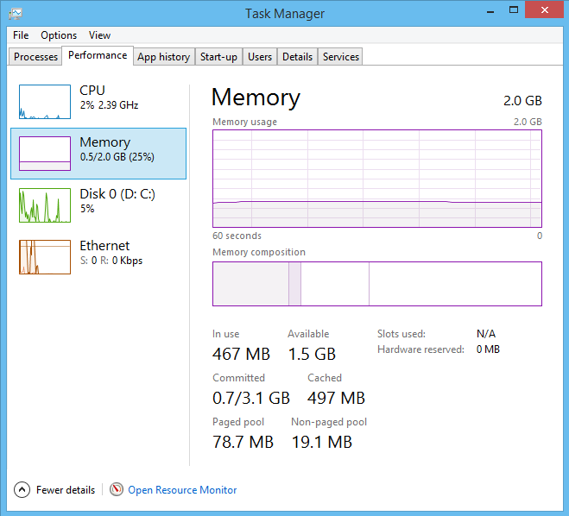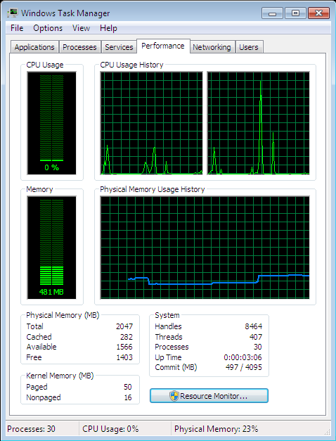The figures below show the Windows 7 and 8.1 task manager interface.

*Figure 2: Windows 8.1 Task Manager*

*Figure 1: Windows 7 Task Manager*

Both Windows 7 and 8.1 task manager can be opened by right click the taskbar and select “Task Manager”. The comparison of memory management are done by observing the memory composition between Windows 7 and 8.1. As you can see, the memory in used by Windows 8.1 (467MB) is slightly less than Windows 7 (481 MB). This is because Windows 8.1 has implemented a new technique known as Memory Combining. According to (askvg, 2016), this technique allows Windows 8.1 to detect duplicate contents or data across the system memory. After that, it will auto free up the duplicate data and allow only one single copy. Thus, this significantly increases the available memory space up to 100 MBs

## Windows 7 Clean Installation Process (boot from DVD)

The following procedures will explain and guide the user to deploy Windows 7 – Home Basic edition operating system on a computer. During this process, all the data and information that saved on the computer’s disk will be erased and reformatted. Therefore, the users are recommended to back up their data first before performing the installation.

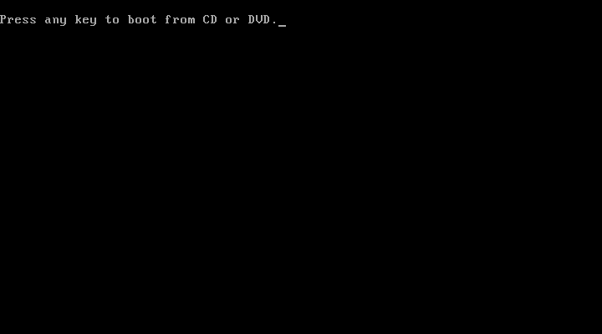Steps 1: Turn on the computer and insert the Windows 7 – Home Basic installation disc into the DVD driver. After that, the following screen will be displayed. The users are required to press any key in order to continue the installation. In some cases, the users might need to boot the installation disc by modify the computer’s BIOS settings. (Screenshot 1).

*Screenshot 1*

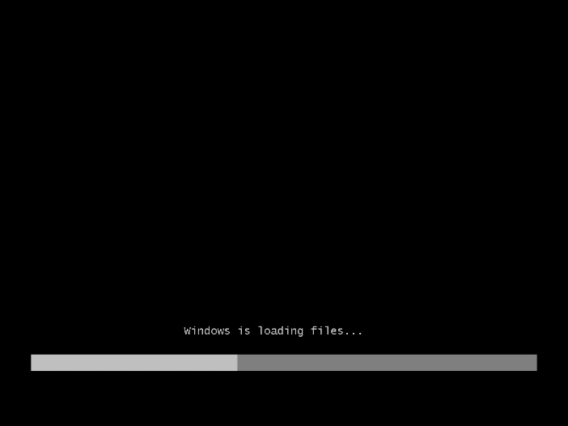Step 2: A progress indicator will appear to indicate that the Windows is loading the required files for installation. (Screenshot 2)

*Screenshot 2*

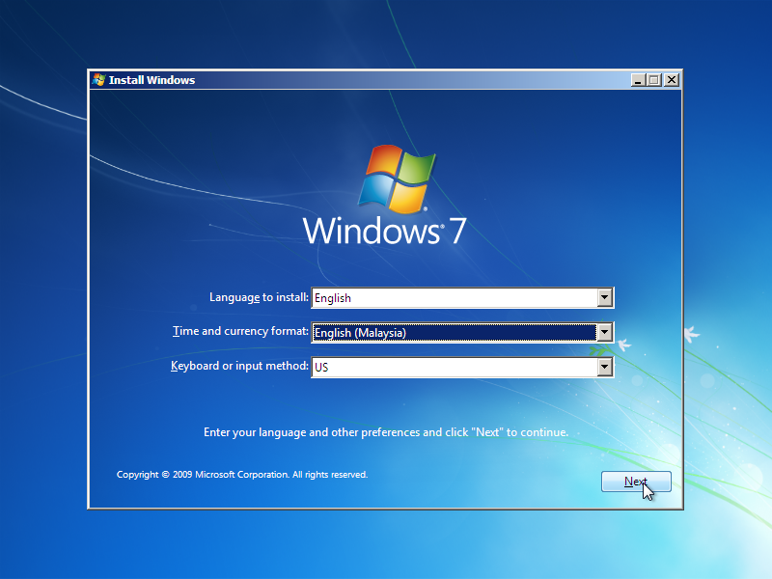Step 3: After finishing loading, the “Install Windows” form will be appeared as following. After selecting the language to install, time/currency format and keyboard input method, press “Next” button to continue. (Screenshot 3).

*Screenshot 3*

Step 4: Click the “Install Now” button to continue. (Screenshot 4).

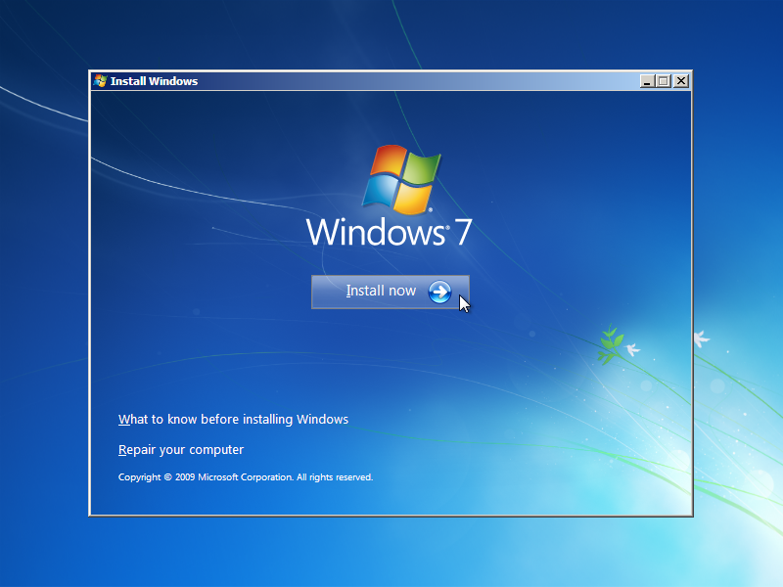Step 5: The “License terms” page will appear as following. Tick the “I accept the license terms” 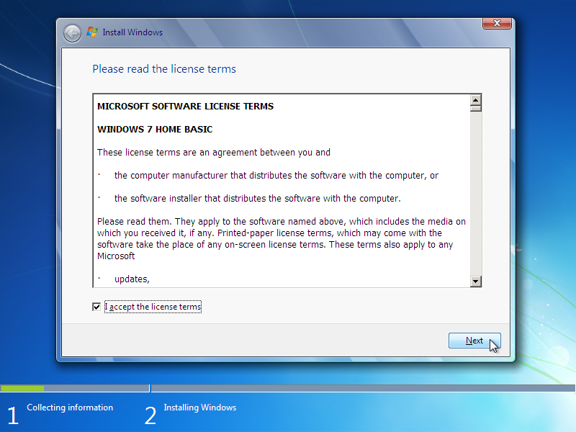checkbox and click “Next” button to continue. (Screenshot 5)

*Screenshot 4*

*Screenshot 5*

Step 6: Click on the “Custom (advanced)” option. The “Upgrade” option is disabled because it doesn’t function in Clean Installation method. (Screenshot 6)

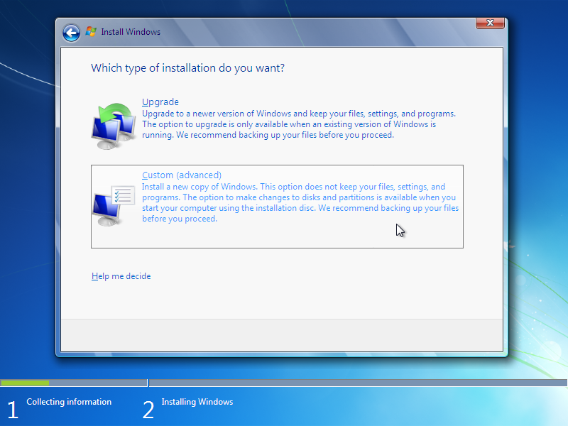

*Screenshot 6*

Step 7: Click on “Drive option (advanced)”. (Screenshot 7) In this case, the disk is blank and unallocated so it is required to create a new partition. (Screenshot 8) Press “OK” button to continue. (Screenshot 9). Enter the amount of capacity that you want and click “Apply” button. (Screenshot 10).

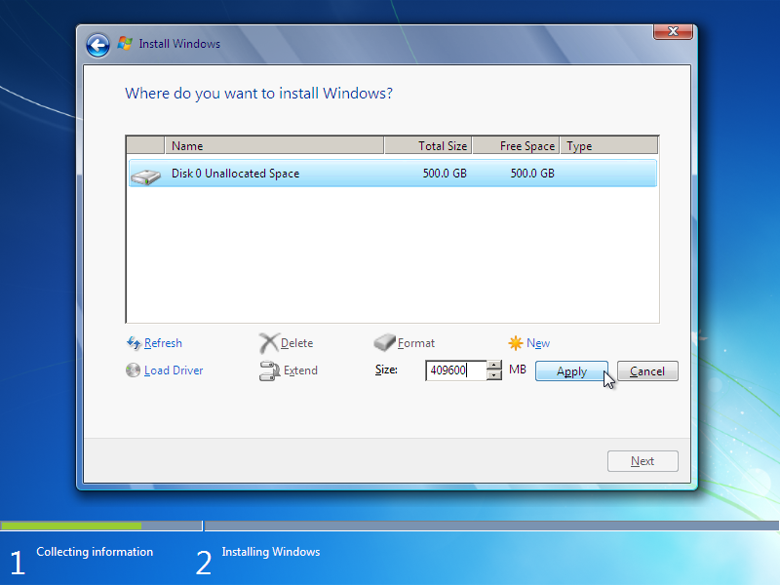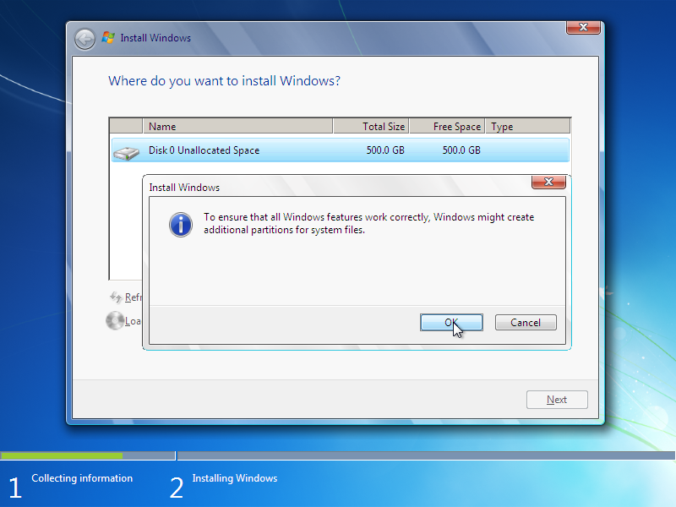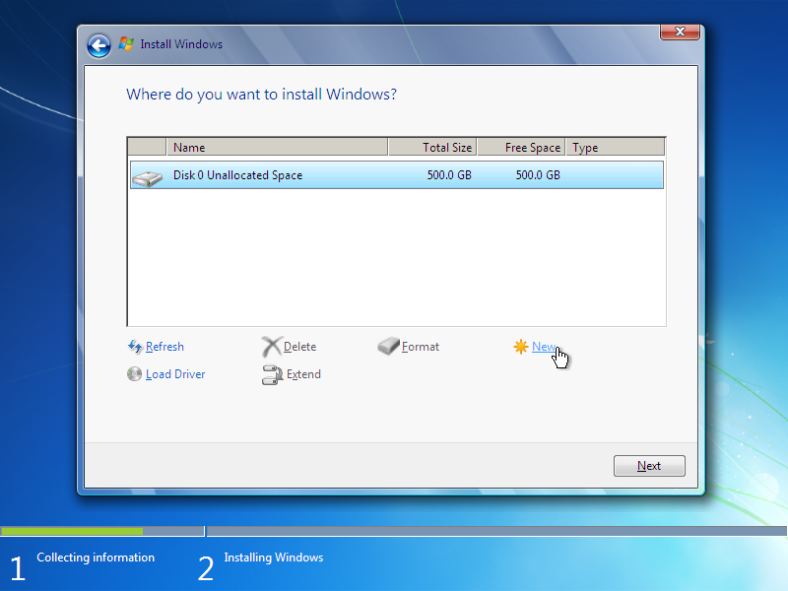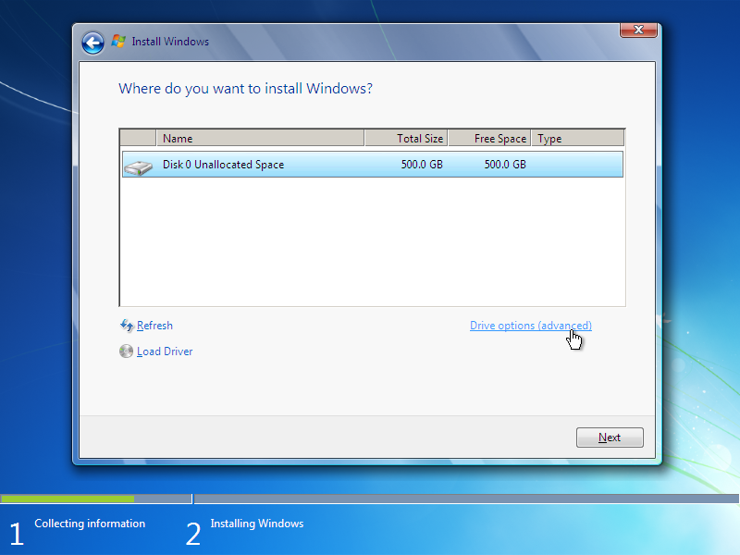

*Screenshot 10*

*Screenshot 9*

*Screenshot 8*

*Screenshot 7*

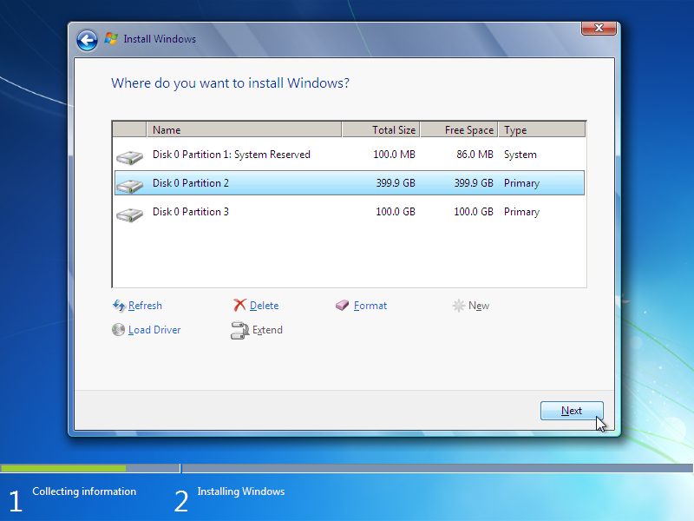Repeat step 7 to create other partition. Remember that Windows 7 requires at least 16GB (32-bit) or 20 GB (64-bit) hard disk space. Select the partition on which the Windows 7 will be installed and click “Next” button. (Screenshot 11).

*Screenshot 11*

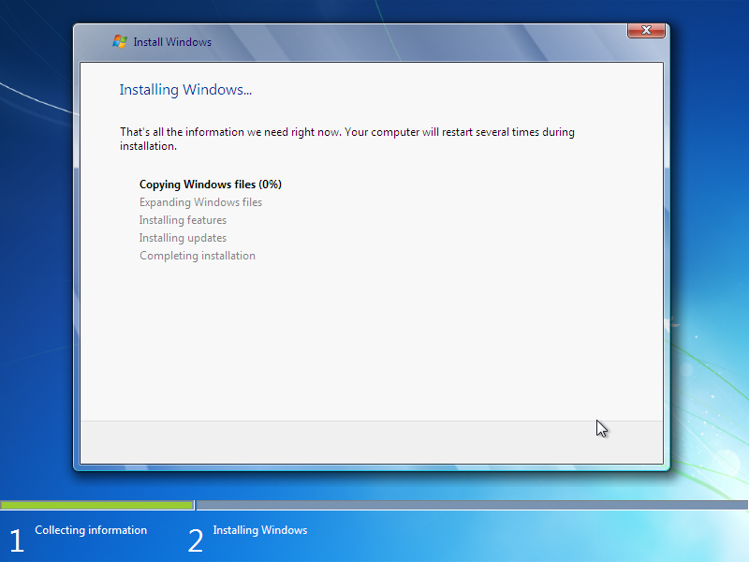Step 8: After that, the computer will start to install the Windows 7. It may takes several minutes to complete the installation depends on the computer’s speed. (Screenshot 12).

*Screenshot 12*

Step 9: During the installation, the computer will reboot 2 times. Do not press any key during the reboot process, otherwise the installation process will start over again. On the second reboot, the “Set Up Windows” form will be appeared. Enter a name for the account of your system and a name for the computer. Click “Next: to continue. (Screenshot 13)

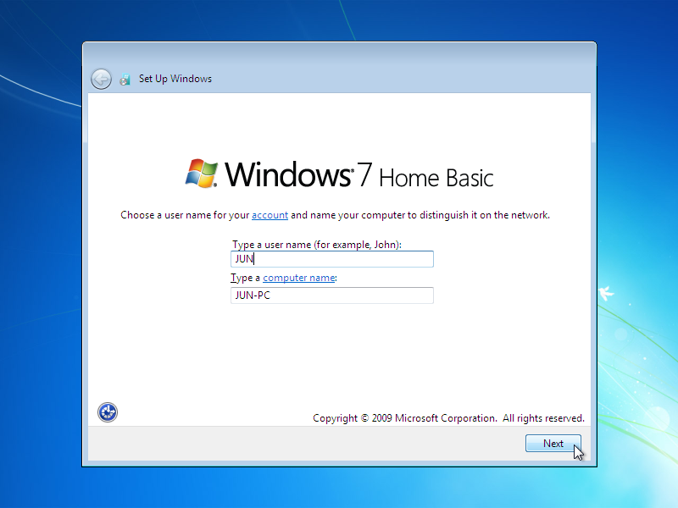

*Screenshot 13*

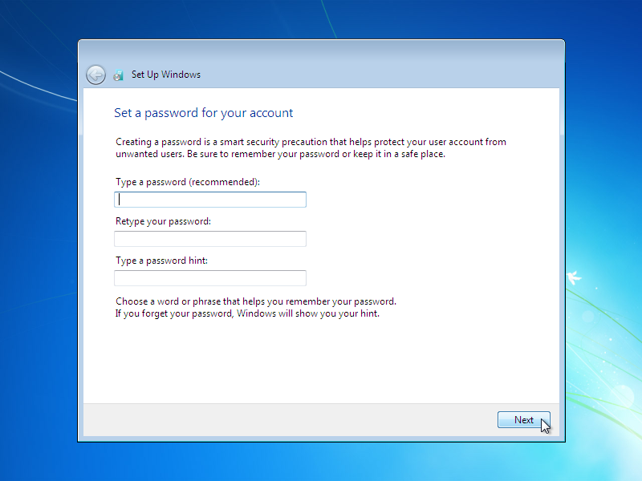Step 10: Set a password for the account that just created. Set a password hint to remind the user of the password in future. (Screenshot 14)Step 11: Enter the Windows product key which can be found on the installation label that attached with the installation disc when purchased. The users can skip this step and activate the Windows afterward by telephone or other ways. Click “Next” button to continue. (Screenshot 15)

*Screenshot 14*

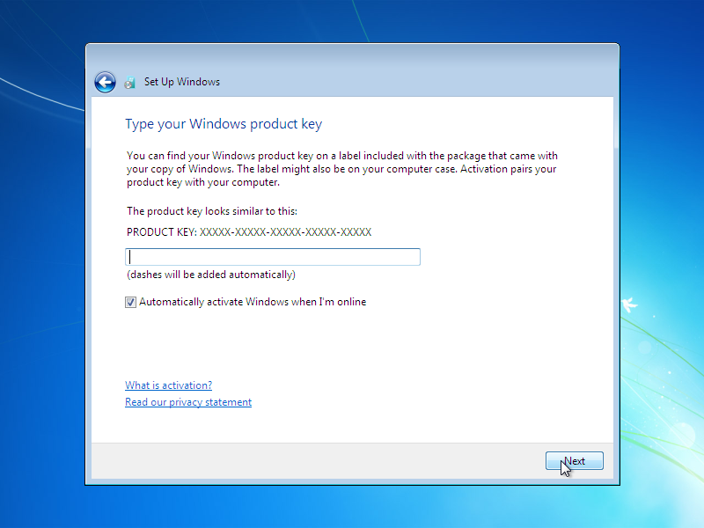

*Screenshot 15*

Step 12: Click one of the options to set up the computer’s security settings. In this case, the users are recommended to choose “Use recommended settings” option. (Screenshot 16)

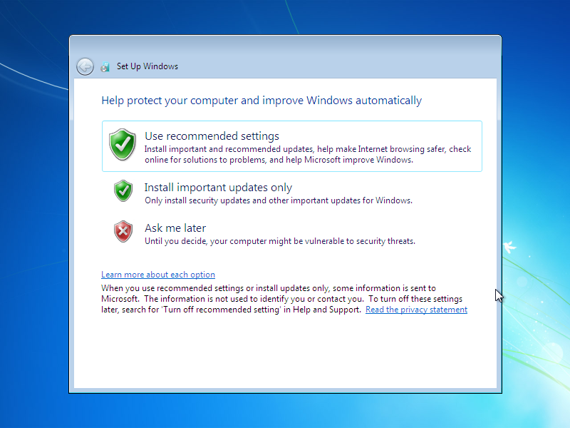

*Screenshot 16*

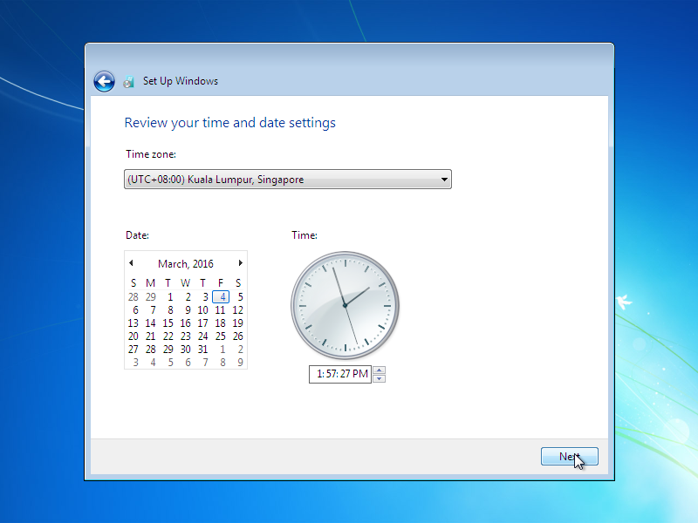Step 13: Select the time zone in which the computer will be running. Select appropriate time and date and click the “Next” button. (Screenshot 17).

*Screenshot 17*

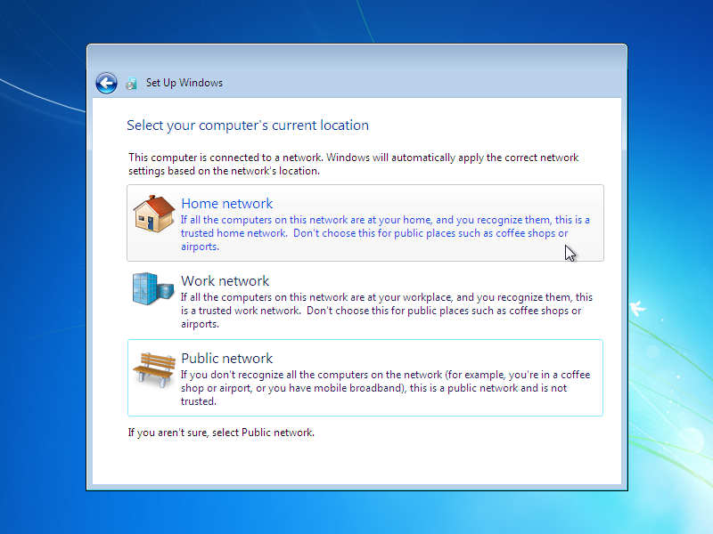Step 14: After that, the users are required to select the computer’s network location. Select the appropriate option based on the computer’s normal location. (Noted that this page will occur only when the computer detected and configured a network connection.). (Screenshot 18).Step 15: The following screen will occur which indicate that the computer is finalizing the installation process (Screenshot 19), followed by the Windows 7 “Welcome” screen. (Screenshot 20).

*Screenshot 18*

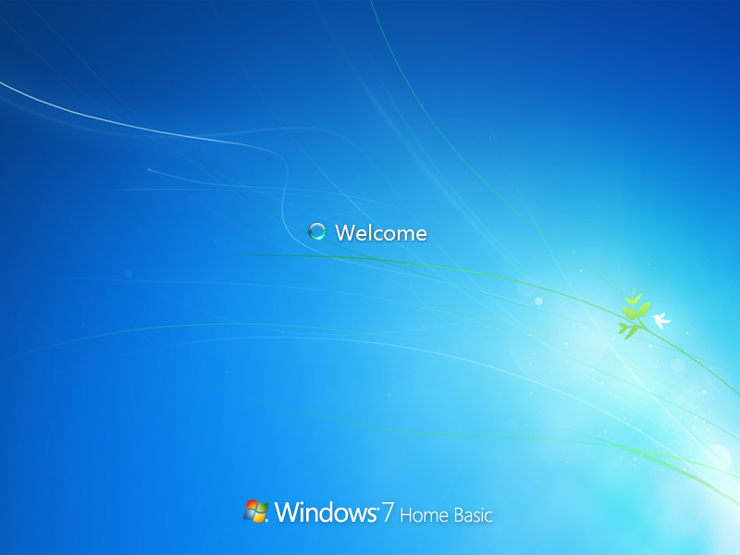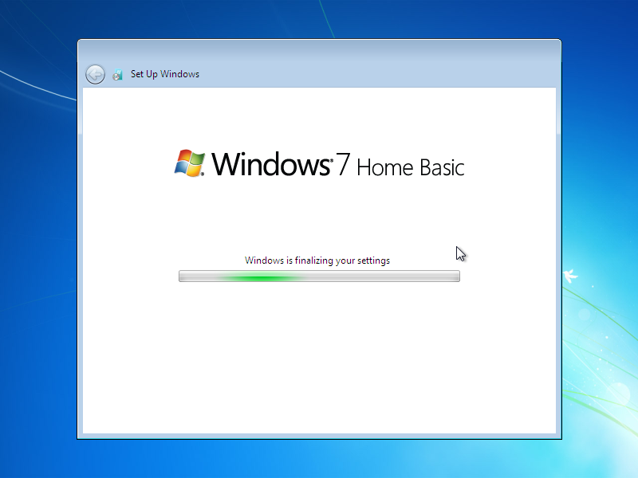

*Screenshot 20*

*Screenshot 19*

Step 16: The Windows 7 installation process is done at this point. The users may remove the installation disk from the DVD driver. (Screenshot 21).

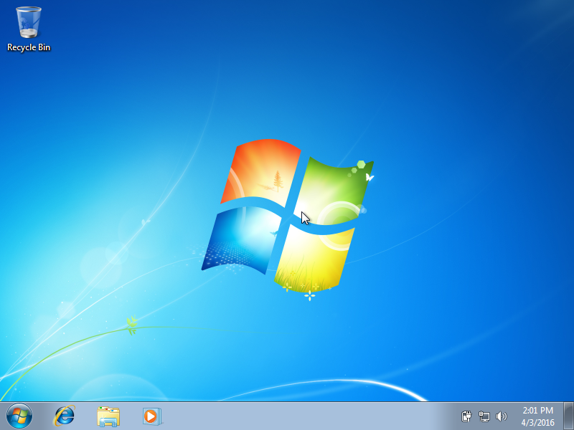

*Screenshot 21*

# Analysis

## User Interface

1. **Start Button**

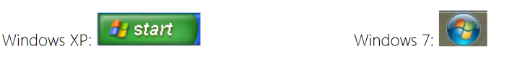

*Figure 3*

Start Button of Window 7 has transformed from rectangle shape (Window XP) to oval shape with remaining same icon above. (Figure 3)

1. 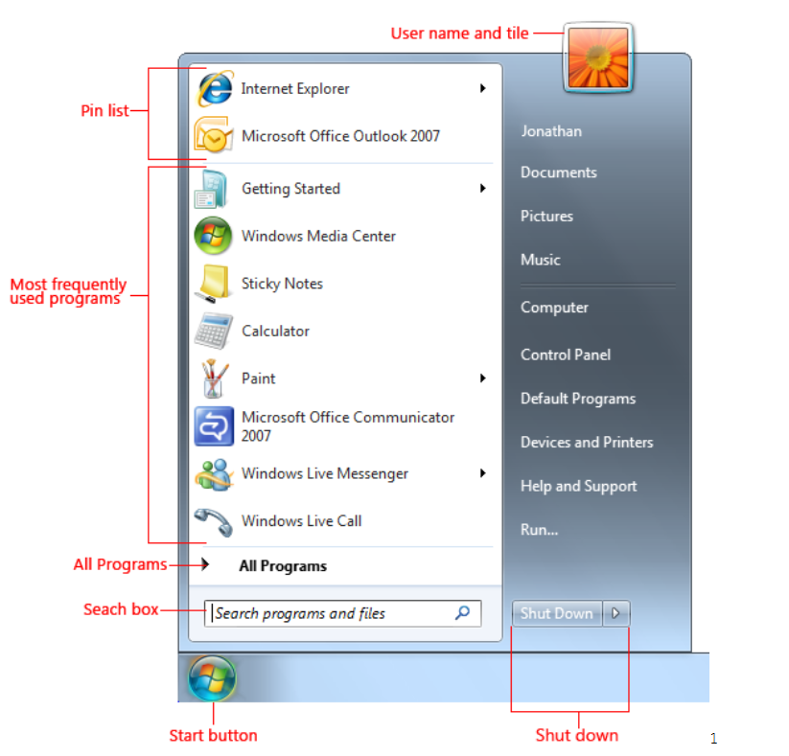**Start Menu**

*Figure 4*

The function of start button is still remain for launching application. In addition, start menu of Window 7 includes search box and pin list to let user find and launch application easily. The left side of start menu is program list while right side of the start menu shows user-related shortcuts.(Figure 4)

1. 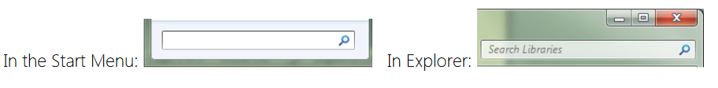Search Box

*Figure 5*

Search box in Window 7 is available in start menu or at top of the window explorer. User can type in search term to view to result directly without press Enter key. (Figure 5)

*Figure 6*

1. Taskbar

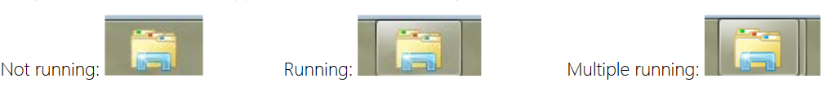

Taskbar of Window 7 has several new features. Any application is able to pin into the taskbar, user can access the application shortcut directly from the taskbar. The taskbar icon also changed to let user know whether the application is under running condition or multiple running condition. (Figure 6)

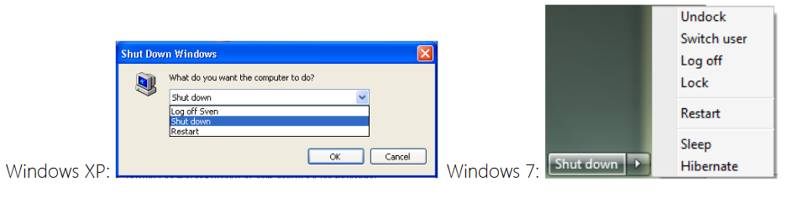

*Figure 7*

1. Shutdown Control

By comparison, shutdown control of Window 7 has increased in its function.

1. Shutdown: Close all application, window and turn off computer. No power in-use
2. Hibernate: Save application state and turn off computer. No power in-use
3. Sleep: Save application state and turn off most devices. Application states saved in RAM. Still using some power.
4. Log Off: Close all applications and end logon session. Computer remains on.
5. Lock: Save application state and continue the logon session. Someone else able to log on.
6. Switch User: Combination of “Lock” and showing the logon screen for another user.

**Feature of User Interface**

1. Aero Snap

Aero Snap feature allows multiple windows to work at the same time with separate the windows by 2 sides. For the previous Window version, users need to adjust the window size manually to split into multiple window, while Window 7 just need to drag to the side of the screen, the window will automatic resize the window to exactly half of the screen size. (Figure 8)

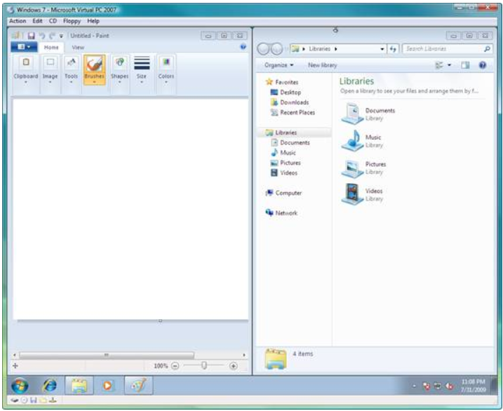

*Figure 8: Aero snap automatically size windows to take up exactly half of the screen*

Except for splitting windows, Aero Snap feature also allow users to maximize and minimize the window by dragging the windows to the top or bottom of the screen.

1. Aero Shake

Aero Shake feature is designed for users to quickly minimize all windows except for the current using window. When there are multiple windows open, user can use the Aero Shake feature by holding current using window and shake it, all other windows will minimize automatically.

1. Aero Peek

Aero Peek feature allow user to have a thumbnail preview of the opened application by hovering cursor above the task icon on the taskbar. The previous Window version only allow user to preview one of the task if there are multiple windows are running at the same time (same application), while Window 7 Aero Peek feature allow users to preview all of the window at the same time.

1. Taskbar

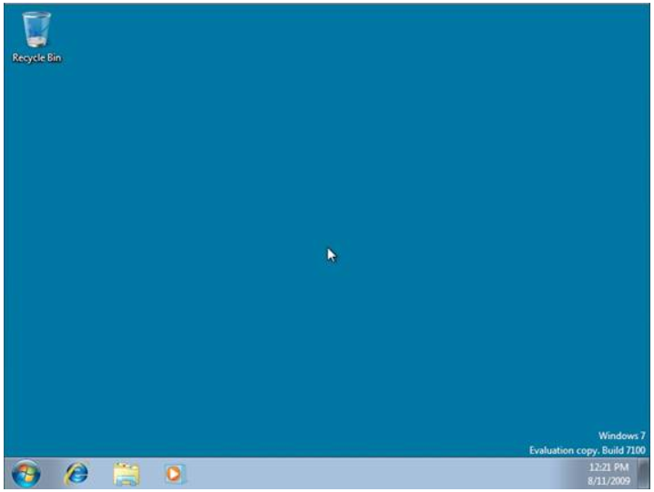Taskbar of Window 7 has includes a new feature, users could pin any application into taskbar and act it as a shortcut. Users just need to drag the application onto the taskbar to pin it easily. To unpin the application, users need to right click the pinned application and select unpin application. (Figure 9)

*Figure 9: Internet Explorer, File Explorer and Window Media Player have been pinned on the taskbar*

1. Jump List

Jump List provides quick access to application features and show users ‘Most Recently Used List’ to let users access the current used files easily. Jump List feature can be found on taskbar and Start Menu. This feature helps user from having to fumble with their list of recently viewed Web pages once Internet Explorer has been opened.

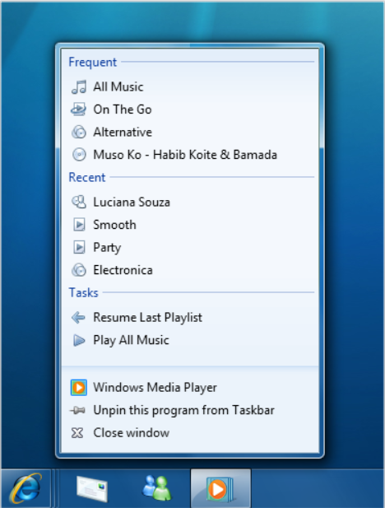

*Figure 10: Jump List shows by right click the application on taskbar*

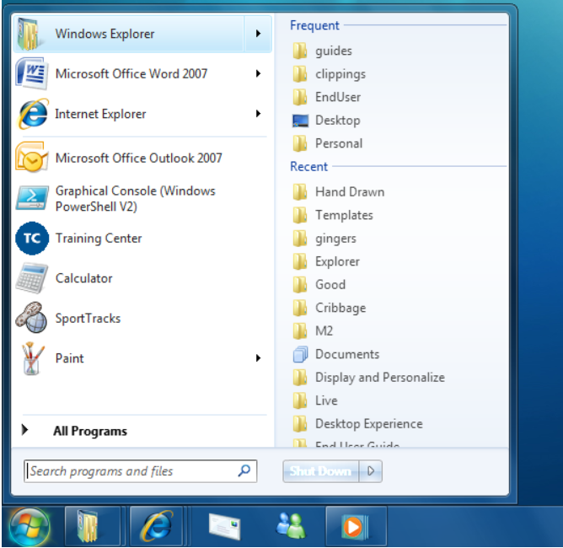

*Figure 11: Jump List found on the Start Menu*

## Process Control Management

Processes contain one or more threads, the Windows thread is a basic executable unit. Threads are scheduled on the base on the common factors, which are the availability of resources such as CPUs and physical memory, priority, fairness and etc. Windows contain long supported multiprocessor systems so that threads could be allocated to separate processors within a computer. (Hart, 2010)

Window 7 implements a preemptive scheduler with a flexible system of priority levels that includes round-robin scheduling within each level. Dynamic priority variation is using for some levels of current thread activities (Stallings, 2005). Preemptive multitasking creates the consequence of concurrent execution of multiple threads from multiple processes. The system can simultaneously execute as many threads as there are processors on a multiprocessor computer (Windows Dev Center, 2016). In Window 7, there were smart heuristic improvements to ensure processes, such as the disk defragmenter are at a lower priority for not obstruct with foreground processes (Dougvj, 2012).

User-mode scheduling (UMS) is a lightweight mechanism that applications to schedule own threads. If a UMS thread interrupted in the kernel, an application can switch between UMS threads in user mode without involving the system scheduler and regain control of the processor. Instead of sharing the thread context of a single thread, each UMS thread has own thread. UMS will be more efficient than thread pools for short-duration work items that require few system calls because it has the ability to switch between threads in user mode. (Windows Dev Center, 2016)

## Deadlock management

Deadlock is a situation where a process enters waiting state when a resources requested by the process are not available because another waiting process request the same resources and the resources is being held by another waiting process. If the process unable to change its state because the resources requested by it are being held or used by another waiting process, then the system is in a deadlock situation.

There are four condition needed to occur at same time for deadlock to occur which include:

1. Mutual exclusion: Where only one process can use the resources, and if other process requests to use that resources, the requesting process must be delayed until the resources has been set free.
2. Hold and wait: Where a process must hold at least one resource and waiting to acquire additional resources that are currently being held by other processes.
3. Non preemption: A resource can be released by the process that holding it, after the process has completed its task.
4. Circular wait: Process “A” is waiting for a resource held by Process “B”, Process “B” is waiting for resource that held by Process “C” and so on.

To prevent deadlock from occur, 4 condition above must be prevented. For mutual exclusion, in general, it cannot be denying the condition as other resources are naturally non-sharable. Meanwhile for Hold and wait condition, protocol will require each process to request and allocated all resources available before it begin execution and allows a process to request resources only when it has none. Lastly for circular wait, way to ensure this condition from occur is to impose a total ordering of all resource type and to require that each process requests resources in an increasing order of enumeration.

**Ostrich Algorithm**

In Windows 7, there is an algorithm called as Ostrich Algorithm to handle deadlocks. For this algorithm, the system will pretend there is no problem when problem occur like an ostrich because for deadlock to occur is a very rare event and the cost of prevention is very high. For Windows 7 onward, deadlock detection is being done by Driver Verifier to predict possible deadlocks. The deadlock kernel debugger extension to investigate exactly what has occurred once deadlock detection finds a violation. Driver verifier is a kind of tool that monitors and stresses drivers to detect illegal function calls or actions that may cause system corruption. (Microsoft, 2016)

## Memory Management

Memory, an essential part of a computer has an important role for storing temporarily data and information. Generally, memory is referred as primary storage or primary memory. A computer memory is valuable, expensive and limited capacity, therefore, different techniques and algorithms are applied by nowadays operating system to manage the usage of the memory in an effective and efficiency way.

**Virtual Memory in Windows 7**

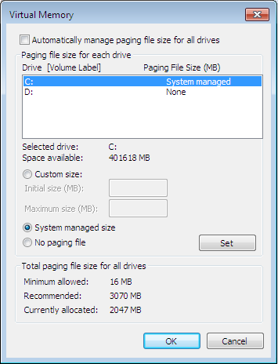In Windows 7 and its earlier versions, Virtual Memory was implemented to allow the operating system to have access and control the physical memory, including the secondary storage. According to (Microsoft, 2016), a computer hard disk is acted as a “Virtual Memory” to store the data and information (paging file) that transferred from the primary memory when the available space of the primary memory is running low. This means the primary memory will only hold the important data that are currently needed for executing certain process. The primary memory will have more spaces to execute processes which are partially loaded in memory, thus, allow multiprogramming.

By default, the size of the Virtual Memory is automatically managed by Windows. Yet, the users can decide and manually change the size of the Virtual Memory if they are facing any issues of running low virtual memory. However, it is recommended to let the operating system to decide on their own as too much paging replacement activities may slow down the computer’s performance. (Figure 12).

*Figure 12*

**Demand Paging with Clustering**

The Virtual Memory in Windows 7 is implemented by using a technique called demand paging with clustering. According to (Russinovich, et al., 2012), this technique allows the memory manager to load the faulted page and multiple small pages that are associated with the faulted page into the primary memory whenever a page fault occurred. This will significant reduce the number of disk read by the processors because most of the programs may execute other small region page that beside the loaded page.

**Logical Pre-fetcher**

However, the implementation of “Demand Paging with Clustering” technique will produce a great number of page faults during the startup of a program or system. This is because the “cluster pages” are also seek and loaded together with the faulted page whenever a program begins its executing. To resolve this issue, Windows had introduced an engine known as “Logical Pre-fetcher”. Based on (Russinovich, et al., 2012), the pre-fetcher can speed up a system or application startup time by tracking the data and information that needed by the application or system during its startup and pre-fetch all the related and necessary batches of pages at one time, thus, it will greatly reduce the number of hard disk read time and improving an application boot time.

Despite the fact that Virtual Memory virtually increases the size of the primary memory which allow multi-tasking, it also produce the page faults problems which will gradually reduce the system performance. The process of moving / switching data to and from the primary memory and secondary memory (hard disk) will cause the processors to spend less time in executing which will result in thrashing. Thus, a page replacement algorithm is needed to determine which page to be replaced in order to minimize the number of page faults occur.

**Clock Algorithms**

Based on (Russinovich, et al., 2012) and (CS, 2016), Windows 7 uses the clock page replacement algorithm to minimize the rate of page faults occur. The clock algorithm is also known as Second Chance algorithm. It is the combination of First in First Out algorithm and Least Recently Used algorithm. It determine the next page victim by using a reference bit that set at each page. As the name suggests, the clock algorithm circulate around the queue and setting the reference bit for each frame in clockwise. The following is the condition of selecting the page victim based on clock algorithm:

-Using FIFO algorithm to select next victim.

-The page will be selected as victim if it is not set with a reference bit.

-The second chance algorithm will be applied if the next page has reference bit set.

1. The reference bit of the page will be cleared (given second chance to stay) and continue to next page until the page that not set with reference bit is found (victim).

2. If all pages are scanned and there are no pages that are not set with reference bit, the search will circle back to the page and start again.

## Secondary Disk Scheduling Management

**C-Look Algorithms**

According to (Russinovich, et al., 2012), C-Look (Circular Look) Algorithm was implemented in Windows to minimize the waiting time of the processors to access data from the secondary disk. This is because the processors are much faster than the hard disk and may cause the processors fall into a situation known as “starvation”.

The C-Look algorithm is almost same as the C-Scan algorithm which both of them move to the other end track without servicing any requesting location when they reach one of the end tracks. However, the C-Look will stop at the last request without reach to the end of the disk whereas the C-Scan does. The C-Look starts from the current head and serving the requests along the path until to the last request and it immediately reverse it direction, go to request that near to the beginning of the disk and start the process again.

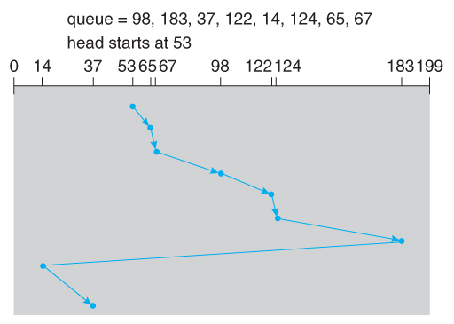The following diagram shows an example of the C-Look algorithm. (Figure 13) Based on (CS, 2016), C-Look algorithm is the algorithm that used by most of the operating system nowadays, including Windows. When comparing to other algorithm, the C-Look has the least total head movement. As a result, the C-Look is the most suitable algorithm to be implemented in system that deal with multi-tasking or multi-processing.

*Figure 13*

## Standard Support

Microsoft has created Windows 7 to give user a trouble-free experience, when problem occurred, Windows 7 notify the user in more intelligent wats and makes resolutions easier and faster. In Windows 7, Action Center has been implemented to keep user’s PC running safely and smoothly. Action Center is a new, integrated Control Panel experience where all tasks and notification takes place. (Figure 14)

*Figure 14*

Besides Action Center, Microsoft also included Windows Troubleshooting in Windows 7 which will help user diagnoses and resolves common operating system and hardware issues by using built-in troubleshooters for various type of problems such as Aero, Browse the Web, Connection to a Shared Folder, Performance and so on. (Figure 15)

*Figure 15*

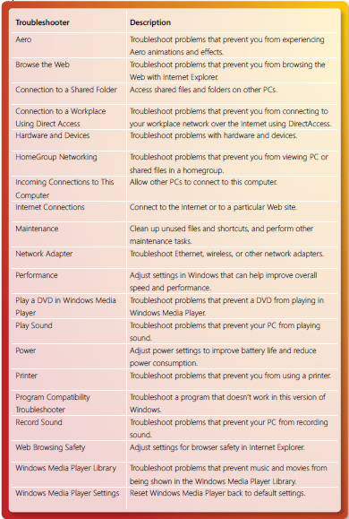Troubleshooting can be access from Control Panel and it offer various type of troubleshooter as shown in diagram below. (Figure 16)

*Figure 16*

Microsoft also has provided after-sales support for their customers, for every Windows user, user can contact Microsoft Store Sales and Customer Support by calling 1-877-696-7786 or Customer service by calling 1800-642-7676. User also can access to their Help and Support by go to their official website <http://windows.microsoft.com/en-us/windows/support> to get assistance from their expert. There are several option allow user to choose from their website, which included Get Started, Email & Communication, Repair & recovery, Security & privacy and so on.

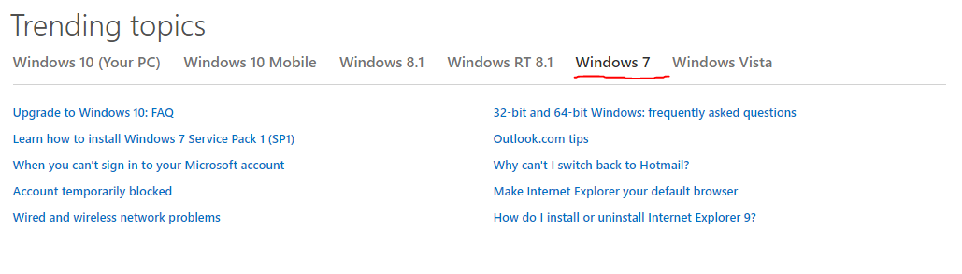

*Figure 17:* shows that trending topics that had been viewed by Windows 7 users.

User also can access to Help and Support by pressing the Start button on their Windows.

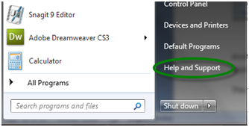

*Figure 18*

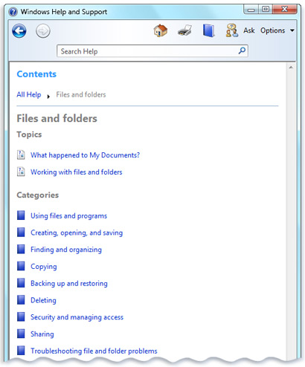There are various choices of topics and category that allow user to choose and seek for help.

*Figure 19*

If user still need more help, user can choose either email to Microsoft for further assistance or they can use online chat with Microsoft experts. (Figure 20)

*Figure 20*

# Limitations / Extensions

**Limitations**

High Software and Hardware Requirement

* Windows 7 require higher software and hardware requirement compare to the previous version of Windows Operating System. For instance, at least 1 GB of RAM Capacity needed for meeting the lowest memory requirement. It supports more towards high end computers and can be used only in highly configures systems. Problem of BSOD (Blue Screen of Death) always encountered in Windows 7 because of the software and hardware changes in the system. (S, 2010)

Bad Support and Service Maintenance

* Windows 7 cannot be upgrade directly from the previous Windows version, it only able to upgrade after formatting the older version of Operating System. It cause the difficulty for common user of Windows Operating System when upgrading to Windows 7. (S, 2010)The driver support of Windows 7 is not providing for old systems and old version of motherboard, some of the features in Windows 7 will be disabled if the user is using old computer. (Anon., 2010)

Application Failure

* Windows 7 encounter application run failure issues, various old software could not be work in Windows 7. (S, 2010)Many applications have failed to run in Windows 7 and some of them are incompatible even though the application is compatible in previous Windows OS version. (David, 2012)

**Extensions**

New Feature Add On

* Graphical User Interface was upgraded in Windows 7 Operating System includes implemented themes, Sticky Notes function and gadgets. It also supports advanced touch and handwriting recognition. (S, 2010)

Performance Improvement

* Windows 7 has fast start up and shut down speed, it could perform faster than previous version of Windows. Windows 7 implemented with automatic defragmentation of the hard disk by setting the perform frequency. Windows 7 perform faster than its predecessors in terms of installation and boot up time. (S, 2010)

Better Security

* Windows defender was upgraded and provides best protection when Windows 7 launch. (S, 2010)Windows 7 is also implement with Bitlocker feature that provides encryption for the internal and external drives which simplify backup and restore processes. (Anon., 2010)

# Minutes of Meetings

## Meeting Minutes #1

**Location:** Level 1-9, TPM

**Date:** Monday 8 February 2016

**Attendance**

Teh Kah Jun, Ng Ji Syuen, Ng Ho Kit

**Presenter**

Teh Kah Jun

**What we have done?**

N/A

**What we are doing?**

The lecturer had assign the assignment project to us and we are discussing which Operating System will be our project investigation target.

**What we will do?**

We start to collect different type of Operating System and their version details and information. We will decide the suitable target operating system as our project title.

## Meeting Minutes #2

**Location:** LV 1-9, TPM

**Date:** Monday 29 February 2016

**Attendance**

Teh Kah Jun, Ng Ji Syuen, Ng Ho Kit

**Presenter**

Teh Kah Jun

**What we have done?**

We have collected the necessary information about the operating system. The target operating system that we have chosen is Windows 7.

**What we are doing?**

We start to write the introduction part of the project and we will let the lecturer check our works once we have done

**What we will do?**

We will continue move on the project to Analysis part. We will divide the task equally among the team members.

## Meeting Minutes #3

**Location:** Syndicate room, TPM

**Date:** Wednesday 9 March 2016

**Attendance**

Teh Kah Jun, Ng Ji Syuen, Ng Ho Kit

**Presenter**

Teh Kah Jun

**What we have done?**

Some of the team members had started their works and some of them had encountered some problems and doubts. They will asked the lecturer opinions on next lecture class.

**What we are doing?**

The team members are investigating and analyzing the “Analysis” part (Deadlock Management, Memory Management and User Interface).

**What we will do?**

We will let the lecturer check our workings once we have finished.

## Meeting Minutes #4

**Location:** G-5 LAB 1, Enterprise 3

**Date:** Thursday 31 March 2016

**Attendance**

Teh Kah Jun, Ng Ji Syuen, Ng Ho Kit

**Presenter**

Teh Kah Jun

**What we have done?**

The “Analysis” part (Deadlock Management, Memory Management and User Interface) were checked by the lecturer. There are some errors have to be made and corrected.

**What we are doing?**

We continue to move on to “Analysis” part (Process Control Management, Disk Scheduling and Standard Support) once all the correction is made.

**What we will do?**

We will let the lecturer check our workings once we have finished.

## Meeting Minutes #5

**Location:** 1-5 ROOM 1, Enterprise 3

**Date:** Monday 12 April 2016

**Attendance**

Teh Kah Jun, Ng Ji Syuen, Ng Ho Kit

**Presenter**

Teh Kah Jun

**What we have done?**

We have finished most of the project.

**What we are doing?**

We are finalizing the documentation and reference all citation.

**What we will do?**

Finally, we will combine all of our works together and prepare a hardcopy and softcopy of our research project.

# References

Anon., 2010. *Vistahunt.* [Online]   
Available at: http://www.vistahunt.com/advantages-and-disadvantages-of-windows7.html  
[Accessed 19 April 2016].

Anon., 2016. *Troy University.* [Online]   
Available at: http://business.troy.edu/Portal/Data/Sites/1/Downloads/technology/topfivenewuserinterfaceelementsinwindows7.pdf  
[Accessed 16 March 2016].

askvg, 2016. *Comparison Between Windows 7 and Windows 8 Memory Management System.* [Online]   
Available at: http://www.askvg.com/comparison-between-windows-7-and-windows-8-memory-management-system/  
[Accessed 3 April 2016].

CS, 2016. *Disk Scheduling Algorithms.* [Online]   
Available at: http://www.cs.iit.edu/~cs561/cs450/disksched/disksched.html  
[Accessed 25 March 2016].

CS, 2016. *Virtual Memory.* [Online]   
Available at: https://www.cs.uic.edu/~jbell/CourseNotes/OperatingSystems/9_VirtualMemory.html  
[Accessed 4 April 2016].

David, M. R., 2012. *CenterBlog.* [Online]   
Available at: http://macflipconverter.centerblog.net/261-what-advantages-and-disadvantages-do-windows-7-have  
[Accessed 19 April 2016].

Dougvj, 2012. *SuperUser.* [Online]   
Available at: http://superuser.com/questions/452780/scheduling-algorithm-used-in-windows-7  
[Accessed 24 July 2016].

Hart, J. M., 2010. *InformIT.* [Online]   
Available at: http://www.informit.com/articles/article.aspx?p=1564827  
[Accessed 28 March 2016].

Microsoft, 2016. *Driver Verifier.* [Online]   
Available at: https://msdn.microsoft.com/en-us/library/windows/hardware/ff545448%28v=vs.85%29.aspx?f=255&MSPPError=-2147217396  
[Accessed 20 March 2016].

Microsoft, 2016. *What is virtual memory?.* [Online]   
Available at: http://windows.microsoft.com/en-us/windows/what-is-virtual-memory#1TC=windows-7  
[Accessed 10 March 2016].

Russinovich, M., Solomon, D. A. & Lonescu, A., 2012. *Windows Internals Part 2.* Sixth ed. Washington: Microsoft Press.

S, B., 2010. *Techulator.* [Online]   
Available at: http://www.techulator.com/resources/3311-Disadvantages-windows.aspx  
[Accessed 19 April 2016].

Stallings, W., 2005. *The Windows Operating System.* [Online]   
Available at: http://avellano.fis.usal.es/~lalonso/amp_inf/windows.pdf  
[Accessed 28 March 2016].

Windows Dev Center, 2016. *Microsoft.* [Online]   
Available at: https://msdn.microsoft.com/en-us/library/windows/desktop/ms681917%28v=vs.85%29.aspx?f=255&MSPPError=-2147217396  
[Accessed 9 April 2016].

Yam, M., 2009. *Windows 7 System Requirements Finalized.* [Online]   
Available at: http://www.tomshardware.com/news/windows-system-requirements-hardware-rc,7701.html  
[Accessed 17 March 2016].